1st implement the

ZCL_FM_TO_API in SE24

2nd below class.

ZCL_REST_GENERIC_RESOURCE- Abstract class

SUPERCLASS: CL_REST_RESOURCE

Step-1:

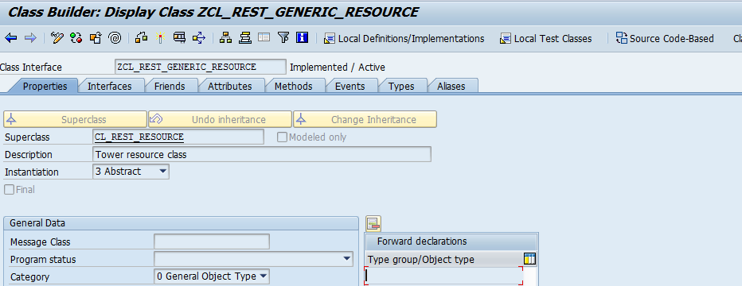

Step-2

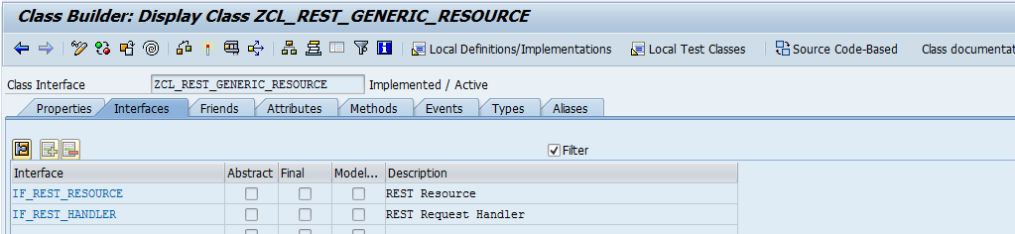

Step-3

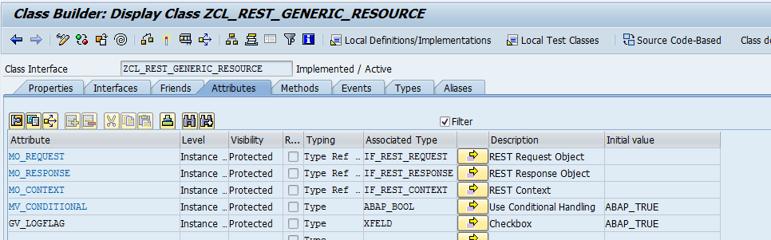

Step-4

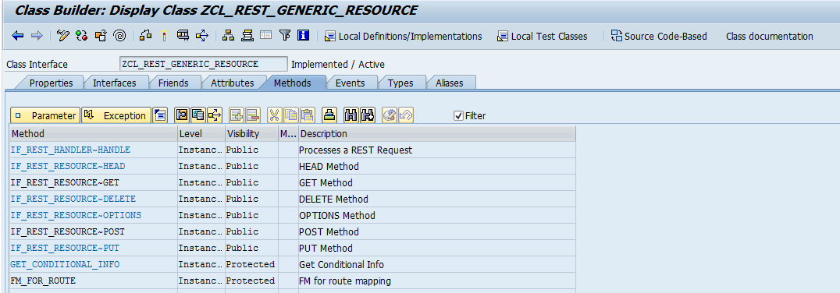

Redefine the FM_for_route() method:

Parameters:

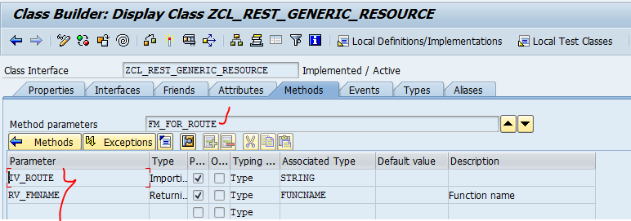

This method is abstract method this is implemented in sub classes only and it is taking the input as “route” like “/routename” and giving the FM name to the output.

**IF_REST_RESOURCE~GET: redefine the “get” mehod.**

**Code:**

METHOD if_rest_resource~get.  
  
  DATA: lv_json_req       TYPE string,  
        lv_json_res       TYPE string,  
        lo_fm2api         TYPE REF TO zcl_fm_to_api,  
        lo_root           TYPE REF TO cx_root,  
        lv_path           TYPE string,  
        lv_route          TYPE string,  
        lv_fmname         TYPE funcname,  
        lv_meta           TYPE string,  
        lt_nvp            TYPE tihttpnvp,  
        lv_template       TYPE xfeld,  
        lv_uri            TYPE string,  
        lv_paramtype      TYPE char3,  
        lv_content_type   TYPE string.  
  
  lt_nvp = mo_request->get_entity( )->get_header_fields( ).  
  lv_route = mo_request->get_entity( )->get_header_field( iv_name = '~path_info' ).  
  IF lv_route = '/fetch-tk'.  
    mo_response->create_entity( )->set_string_data('Token sent. Check response header.' ).  
  ELSE.  
  
    TRANSLATE lv_route TO LOWER CASE.  
    lv_fmname = fm_for_route( lv_route ).  
  
    IF lv_fmname IS INITIAL.  
      CALL METHOD super->if_rest_resource~get( ).  
    ELSE.  
      TRY.  
          lv_uri = mo_request->get_entity( )->get_header_field( iv_name = '~request_uri' ).  
          TRANSLATE lv_uri TO LOWER CASE.  
          IF lv_uri CS 'template=true'.  
            lv_template = abap_true.  
          ENDIF.  
          IF lv_uri CS 'response=true'.  
            lv_paramtype = 'OUT'.  
          ELSE.  
            lv_paramtype = 'IN'.  
          ENDIF.  
  
          lv_json_res = zcl_fm_to_api=>fmmetadata( iv_fmname = lv_fmname iv_template = lv_template iv_paramtype = lv_paramtype ).  
  
          IF lv_uri CS 'format=xml'.  
            CALL TRANSFORMATION id SOURCE XML lv_json_res  
                 RESULT XML lv_json_res.  
            lv_content_type = 'application/xml'.  
          ELSE.  
            lv_content_type = 'application/json'.  
          ENDIF.  
  
        CATCH cx_root INTO lo_root.  
          lv_json_res = lo_root->get_text( ).  
      ENDTRY.  
  
      mo_response->create_entity( )->set_header_field(  iv_name = 'Content-Type' iv_value = lv_content_type ).  
      mo_response->create_entity( )->set_string_data( lv_json_res ).  
  
    ENDIF.  
  ENDIF.  
  
ENDMETHOD.

**Redfine the if_rest_resource~post.**

METHOD if_rest_resource~post.  
  
  DATA: lv_json_req       TYPE string,  
        lv_json_res       TYPE string,  
        lo_fm2api         TYPE REF TO zcl_fm_to_api,  
        lo_root           TYPE REF TO cx_root,  
        lo_logger         TYPE REF TO zcl_rest_logger,  
        lv_path           TYPE string,  
        lv_route          TYPE string,  
        lv_fmname         TYPE funcname,  
        lv_meta           TYPE string,  
        lt_nvp            TYPE tihttpnvp,  
        lv_logging        TYPE string.  
  
  TRY.  
  
  
      lv_logging = mo_request->get_entity( )->get_header_field( iv_name = 'logging' ).  
      IF lv_logging IS NOT INITIAL.  
        TRANSLATE lv_logging TO LOWER CASE.  
        IF lv_logging = 'true'.  
          gv_logflag = abap_true.  
        ELSEIF lv_logging = 'false'.  
          CLEAR gv_logflag.  
        ENDIF.  
      ENDIF.  
  
      IF gv_logflag IS NOT INITIAL.  
        CREATE OBJECT lo_logger  
          EXPORTING  
            io_request = mo_request.  
      ENDIF.  
      lv_route = mo_request->get_entity( )->get_header_field( iv_name = '~path_info' ).  
      TRANSLATE lv_route TO LOWER CASE.  
      lv_fmname = fm_for_route( lv_route ).  
      TRY.  
          CREATE OBJECT lo_fm2api  
            EXPORTING  
              iv_fmname = lv_fmname.  
        CATCH cx_root INTO lo_root.  
          lv_json_res = lo_root->get_text( ).  
      ENDTRY.  
      IF lo_fm2api IS BOUND.  
        lv_json_res = lo_fm2api->reqtores( mo_request->get_entity( )->get_string_data( ) ).  
      ENDIF.  
      IF lo_logger IS BOUND.  
        lo_logger->logout( iv_response = lv_json_res ).  
      ENDIF.  
  
    CATCH cx_root INTO lo_root.  
      lv_json_res = lo_root->get_text( ).  
  ENDTRY.  
  IF lv_json_res IS INITIAL.  
    lv_json_res = 'Unknown error occured'.  
  ENDIF.  
  mo_response->create_entity( )->set_header_field(  iv_name = 'Content-Type' iv_value = 'application/json' ).  
  mo_response->create_entity( )->set_string_data( lv_json_res ).  
  
ENDMETHOD.

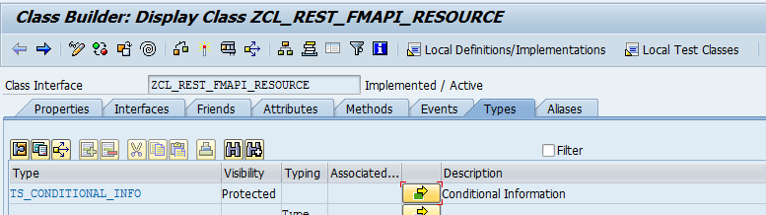

protected section.  
  
  types:  
    BEGIN OF ts_conditional_info,  
          existing TYPE abap_bool,  
          etag TYPE rest_etag_s,  
          modification_date TYPE timestamp,  
          status TYPE i,  
          response TYPE REF TO if_rest_response,  
        END OF ts_conditional_info .  
  
  data MO_REQUEST type ref to IF_REST_REQUEST .  
  data MO_RESPONSE type ref to IF_REST_RESPONSE .  
  data MO_CONTEXT type ref to IF_REST_CONTEXT .  
  type-pools ABAP .  
  data MV_CONDITIONAL type ABAP_BOOL value ABAP_TRUE. .  
  
  methods GET_CONDITIONAL_INFO  
    importing  
      !IV_METHOD type STRING  
    exporting  
      !EV_EXISTING type ABAP_BOOL  
      !EV_STATUS type I  
      !ES_ETAG type REST_ETAG_S  
      !EV_MODIFICATION_DATE type TIMESTAMP  
      !EV_GET_RESPONSE type ABAP_BOOL .

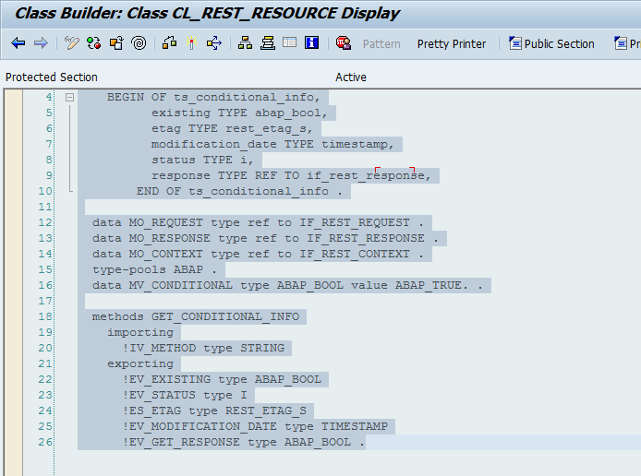

REST API SERVICE CREATION USING GENERIC Z CLASSES

# Introduction

We have created a ready-to-use solution for creating REST APIs in 5 easy steps. This document demonstrates these steps.

# Requirement

If the requirement is to create and expose wrapper REST APIs for existing/newly created function modules, this solution can be used. Please note, this solution is only available in D91 and yet to be created in DER/D90/HD1.

# Features

On using this solution, the following features are inherited automatically.

1. Logging and data tracking
2. X-csrf token validation
3. Implicit data conversion
4. Metadata generation
5. Template generation

# Pre-requisites

* SICF Service name should be decided in advance.
* Function module(s) should exist to perform the core task of the required API.
* Unique route name should be decided for mapping to each of the function modules.

# Steps with Example

For example, let us assume there is requirement to create a new REST API service named DEMOREST for the following 3 function modules with routes as mentioned below:

|  |  |
| --- | --- |
| **FM Name** | **Route** |
| Z_TOWER_PR_CREATE | /pr-create |
| Z_TOWER_PR_CHANGE | /pr-change |
| Z_TOWER_PR_READ | /pr-read |

The solution can be created using the following 4 steps:

## Step 1🡺 Inherit generic handler class to create your handler class

Create a child final class by inheriting abstract class **ZCL_REST_GENERIC_HANDLER** as below (T-code SE24):

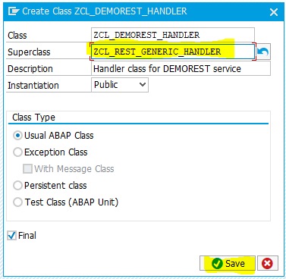

## Step 2🡪 Re-Define abstract method ‘SET_RESOURCE’

In this step, we need to specify the RESOURCE class name (Created in step 3), by setting global attribute GV_RESOURCE_CLASS:

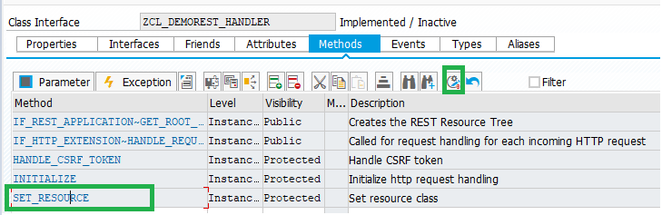

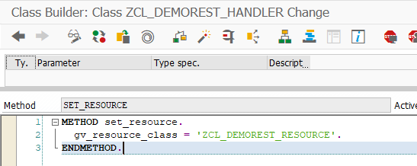

## Step 3: Inherit generic resource class to create your resource class

Create a child final class by inheriting abstract class **ZCL_REST_GENERIC_RESOURCE** as below (T-code SE24):

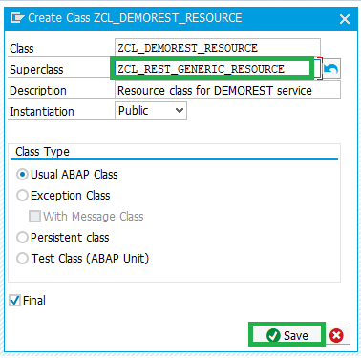

Note: Make sure that the name of the new class is same as specified in step 2.

## Step 4🡪 Re-Define abstract method ‘FM_FOR_ROUTE’

In this step, we need to specify route and Function Module mapping:

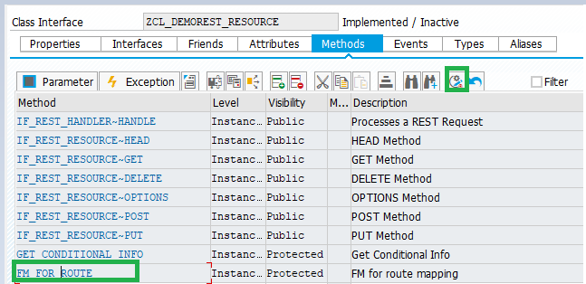

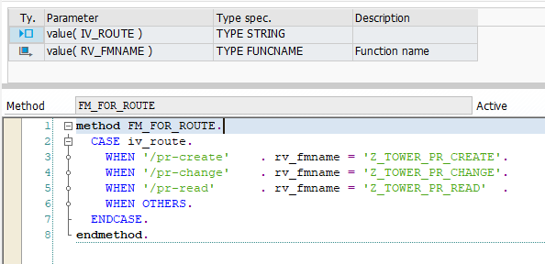

## Step 5 🡪 Create SICF Node and map Handler class created

Go to t-code SICF and create new sub element at your desired path and map Handler class name as below:

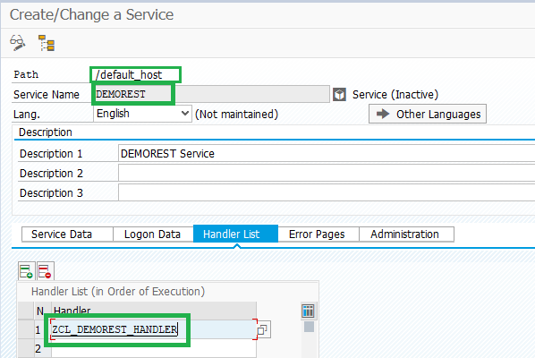

Note: Ensure to activate the node after creation:

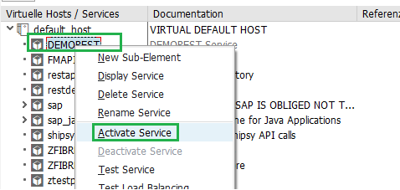

# Conclusion

That’s all required from development end. Once the service is activated, your rest service is ready for testing, loaded with in-built features mentioned.

# Generated URLs

The service node link can be found by right clicking the service in SICF and then clicking on ‘Test service’. This action should fire-up your browser and you can copy the link.

Please note, to access the core service, you still need to append the route for the required FM in the generated URL at end.

For example, in this case Following URLs are active for FM ‘Z_TOWER_PR_READ’:

|  |  |  |
| --- | --- | --- |
| Method-Type | URL | Result |
| GET | <http://deverpd91.bss.dev.jio.com:8000/demorest/pr-read?sap-client=112> | {      "SIGNATURE": {          "NAME": "Z_TOWER_PR_READ",          "DESCRIPTION": "PR creation",          "IMPORTING": [              {                  "PARAMETER": "INPUT",                  "REQUIRED": "false"              }          ],          "EXPORTING": [              {                  "PARAMETER": "OUTPUT",                  "REQUIRED": "false"              }          ],          "CHANGING": [],          "TABLES": []      },      "METADATA": {          "INPUT": {              "UNIQUE_ID": {                  "DATATYPE": "CHAR",                  "LENGTH": 18,                  "DESCRIPTION": "Length 18 text"              },              "PR_NUM": {                  "DATATYPE": "CHAR",                  "LENGTH": 10,                  "DESCRIPTION": "Purchase Requisition Number"              }          }      }  } |